Adaptive Explainable AI with Dual-Mode Explanations

This project implements an adaptive explainability system that dynamically switches between two explanation modes based on simulated user cognitive load. The system is designed for high-stakes decision-making domains (such as healthcare risk assessment) where users need to understand AI predictions but have varying mental capacity to process explanations .

The project synthesizes three influential research papers:
- AXTF (Adaptive Explainability Trust Framework) – Provides the conceptual framework for detecting user state and adapting explanations accordingly
- PRISM (Probability Reconstruction via Shapley Measures) – Offers a detailed, quantitative explanation method showing factor contributions
- CAM (Concept and Argumentation Model) – Provides a simple, conversational explanation method using concept hierarchies

Core Innovation
The key innovation is the adaptive switching mechanism: when user cognitive load is low, the system provides detailed, factor-by-factor explanations (PRISM-style); when load is high, it switches to simple, conversational explanations (CAM-style). This aligns with recent research showing that explanation effectiveness depends on user context and cognitive state

The Challenge
Artificial Intelligence systems are increasingly used in high-stakes domains like healthcare, finance, and emergency response. While these systems can make accurate predictions, their "black box" nature creates a fundamental problem: users cannot trust what they do not understand

Current explainable AI (XAI) approaches have three critical limitations:

Limitation | Description | Impact
Static Explanations | Most systems provide the same explanation format to all users, regardless of context | A stressed user cannot process detailed explanations; a curious user needs more depth
One-Size-Fits-All | Explanations don't adapt to individual user expertise or cognitive state | Novices need simplicity; experts need detail; both needs are unmet
No User State Awareness | Systems don't detect when users are overloaded, stressed, or confused | Explanations are delivered at the wrong time, in the wrong format

The Research Gap
While individual papers have addressed parts of this problem :
- AXTF proposes the idea of adaptive explanations but doesn't implement it
- PRISM provides detailed explanations but doesn't adapt
- CAM provides simple explanations but doesn't adapt
No existing system combines all three: detailed explanations, simple explanations, AND adaptive switching based on user state.

2.3 Research Questions
This project addresses three research questions:
- RQ1: Can we implement a simplified version of PRISM-style detailed explanations using logistic regression coefficients as proxies for Shapley values?
- RQ2: Can we implement a simplified version of CAM-style conversational explanations using manually defined concept hierarchies and contribution aggregation?
- RQ3: Can an adaptive switching mechanism between these two explanation modes provide a more flexible and user-centered explanation experience?

Project Objectives
Primary Objectives
ID | Objective | Purpose
S1 | Document all code with clear comments and markdown explanations | Educational value; GitHub portfolio
S2 | Create system architecture diagrams | Visual communication of design
S3 | Save trained models and preprocessors for deployment | Reusability
S4 | Outline publication pathway | Research dissemination

Theoretical Framework
Explainable AI systems must balance three competing objectives :
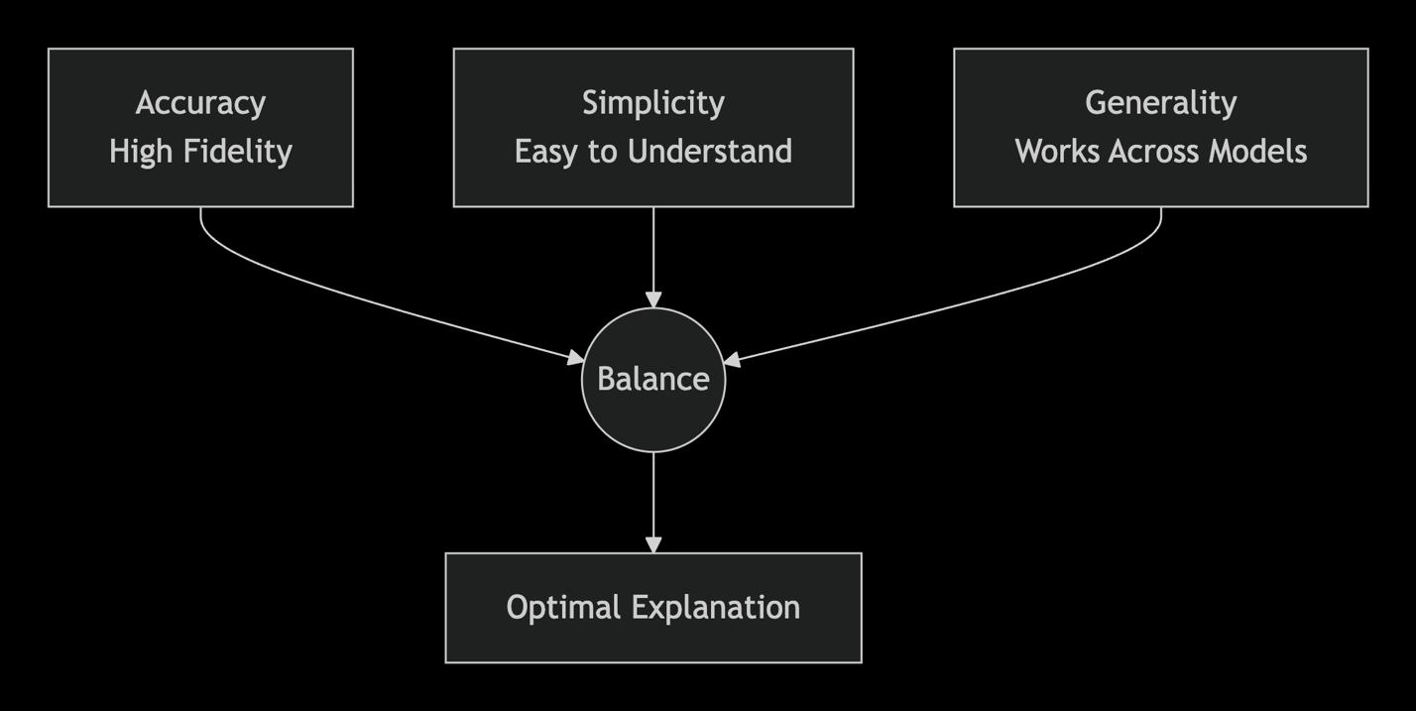
- Accuracy (Fidelity): How well the explanation reflects the model's true decision process
- Simplicity: How easily a human can understand the explanation
- Generality: How widely applicable the explanation method is
- Trade-off: Our project accepts lower fidelity in simplified explanations in exchange for higher simplicity when users are stressed. This is a deliberate design choice informed by cognitive load theory

Cognitive Load Theory Applied
Cognitive load refers to the mental effort being used in working memory. In high-stakes environments:

Load Level | User State | Appropriate Explanation
Low | Calm, focused, has time | Detailed, factor-by-factor, quantitative
Medium | Somewhat busy, moderate stress | Hybrid (can be explored)
High | Stressed, overloaded, time-pressure | Simple, conversational

Our adaptive system simulates this by switching at a threshold
Theory Formulation
Following the theoretical framework in XAI design , explanation effectiveness can be measured by mutual information:
I(Y;E∣X)
Where:
$Y$ = model prediction
$E$ = explanation
$X$ = input data

Higher mutual information means the explanation contains more information about why the prediction was made.

System Architecture
High-Level Architecture
Based on the X-SYS reference architecture for interactive explanation systems , our system follows a four-layer design:
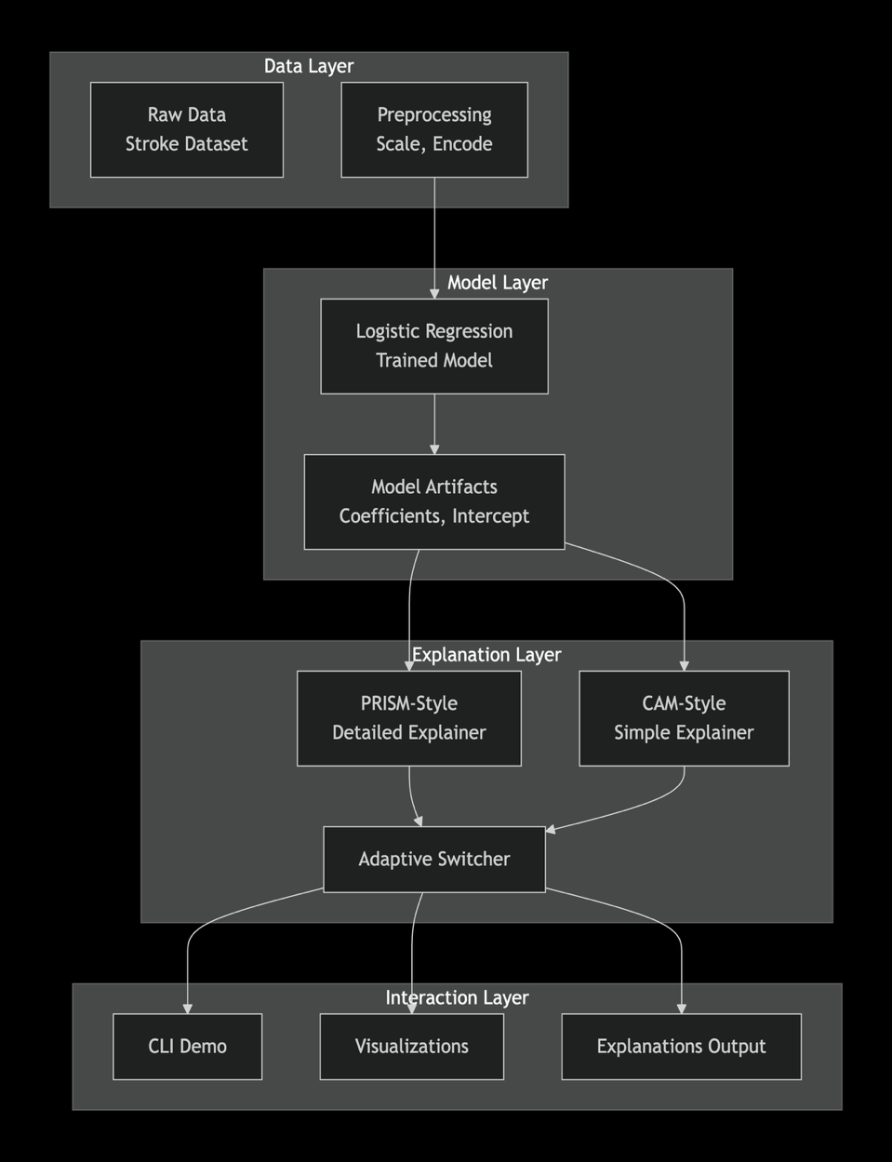
Layer Responsibilities :
- Data Layer: Load, clean, preprocess, and split the stroke dataset
- Model Layer: Train and store the logistic regression model
- Explanation Layer: Generate both detailed and simple explanations; manage adaptation
- Interaction Layer: Present explanations to users; accept user input

Component Details

Data Preprocessing Pipeline

Explanation Generation Pipeline
PRISM-Style Detailed Explanation:
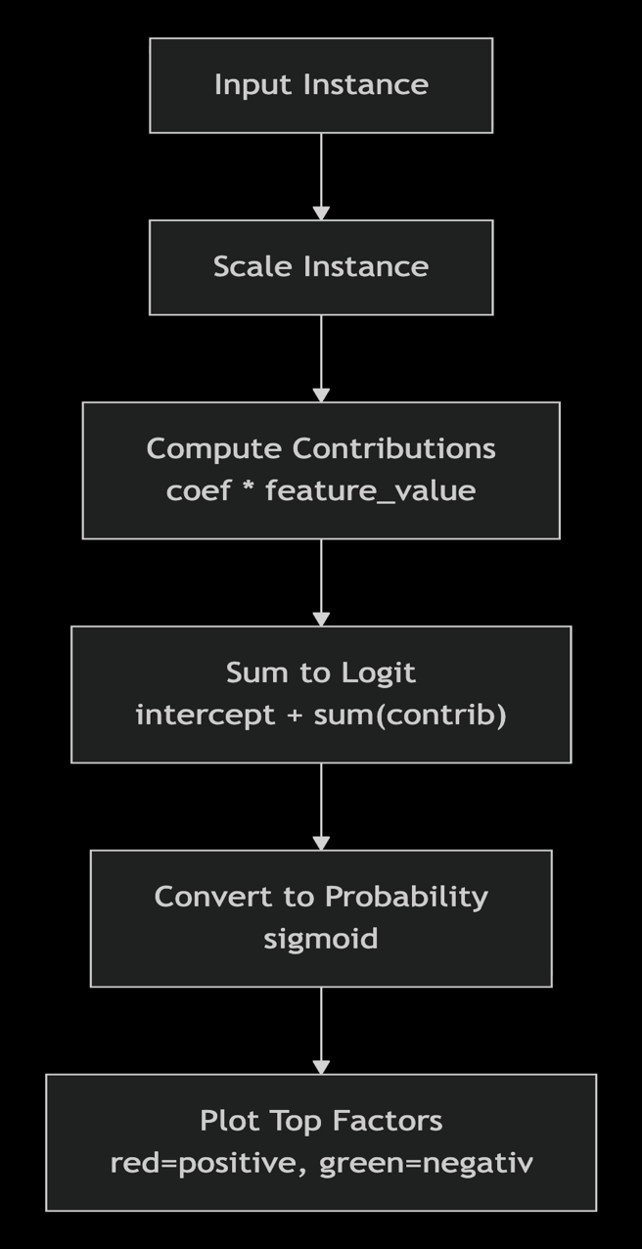

CAM-Style Simple Explanation:
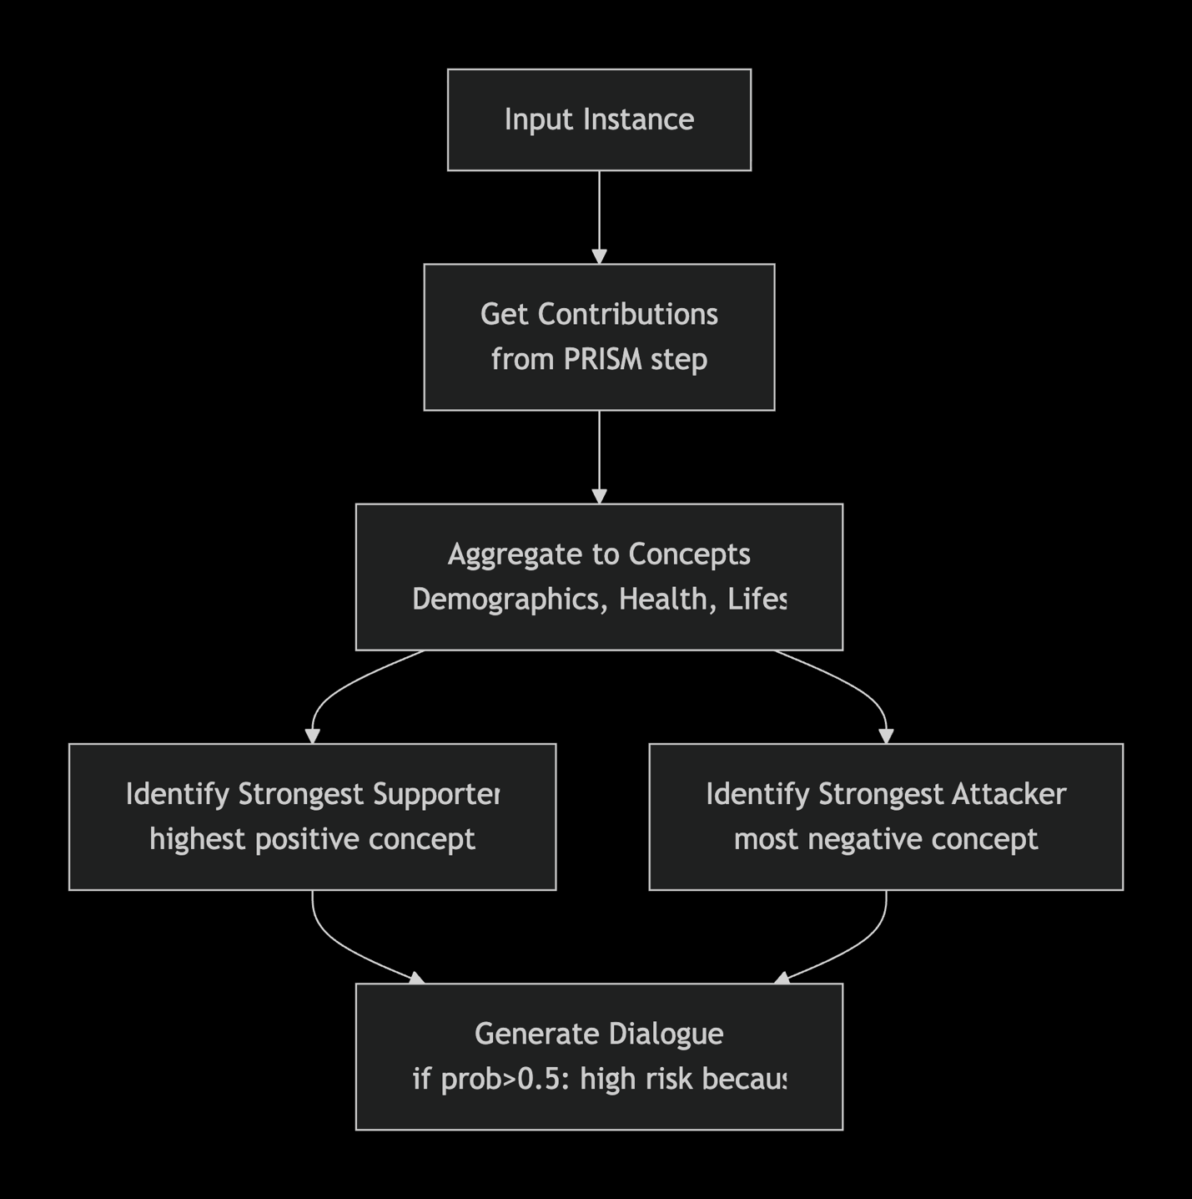

Data Flow
The complete data flow through the system :
- User Input: Instance features (or random selection)
- Preprocessing: Scale using fitted StandardScaler
- Prediction: Model predicts probability
- Contribution Calculation: Compute per-feature contributions
- Mode Selection: Based on counter threshold (detailed first N, then simple)
- Explanation Generation:
>If detailed: Show bar chart of top factors
>If simple: Show conversational dialogue
- Counter Update: Increment for next query

Concept Hierarchy Design
Stroke Risk Factors
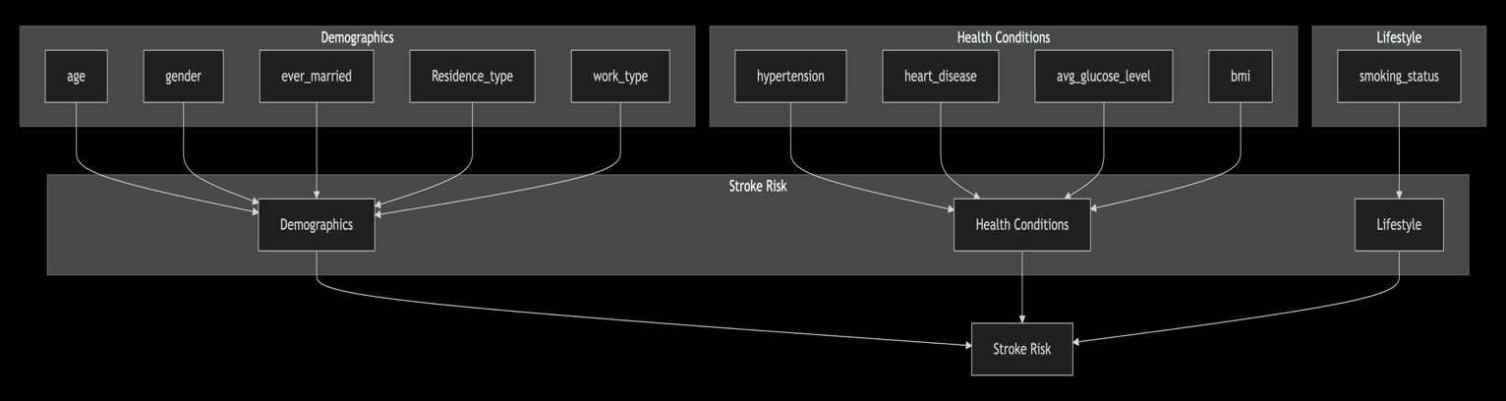

Concept Definitions
Concept | Features Included | Interpretation
Demographics | age, gender, ever_married, Residence_type, work_type | Who the person is (age, gender, marital status, where they live, work)
Health Conditions | hypertension, heart_disease, avg_glucose_level, bmi | Physical health indicators
Lifestyle | smoking_status | Behavioral factors

Contribution Aggregation
For a given instance, concept contribution = sum of feature contributions within that concept:
Contribution concept=∑ f∈conceptβf⋅x f,scaled
​Where:
- $\beta_f$ = model coefficient for feature $f$
- $x_{f,scaled}$ = scaled value of feature $f$ for this instance

Evaluation Metrics
Model Performance Metrics
Metric | Description | Target
Accuracy | (TP + TN) / (Total) | > 0.80
AUC | Area under ROC curve | > 0.80
Precision | TP / (TP + FP) | Monitor
Recall | TP / (TP + FN) | Monitor

Explanation Quality Metrics
Following the XAI metrics framework :

Metric | Description | How to Measure
Fidelity | Does explanation match model behavior? | Compare simplified explanation with full model output
Stability | Are similar inputs given similar explanations? | Add small noise, measure explanation change
Comprehensibility | Can users understand the explanation? | User study (future work)
Actionability | Does explanation help users make decisions? | User study (future work)

Adaptive System Metrics
Metric | Description | Measurement
Switching Accuracy | Does system switch at correct threshold? | Verify counter logic
Mode Distribution | Ratio of detailed to simple explanations | Track counts
Response Time | Time to generate explanation | Measure in code

